# ENEL 453 Laboratory 2

## Section B02

Benjamin Hilborn & Brendon Kopp

Lab held on February 3rd, 2015

We declare that this laboratory report is entirely our own work and includes no material which has been copied from any other source excepting that material which is clearly identified as the work of others.

# PART 5

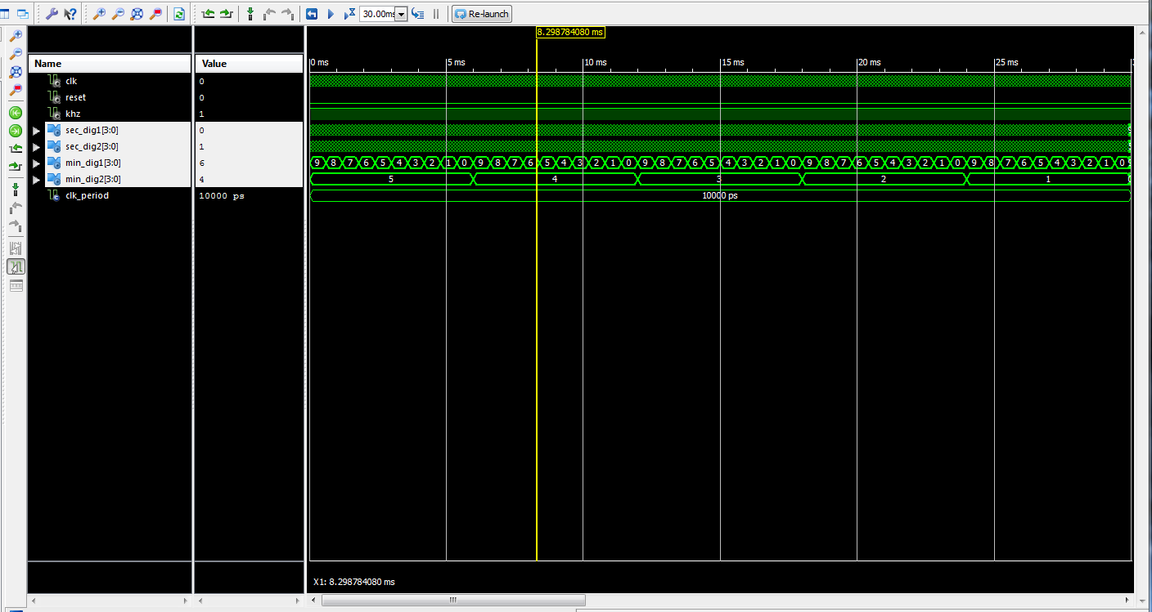

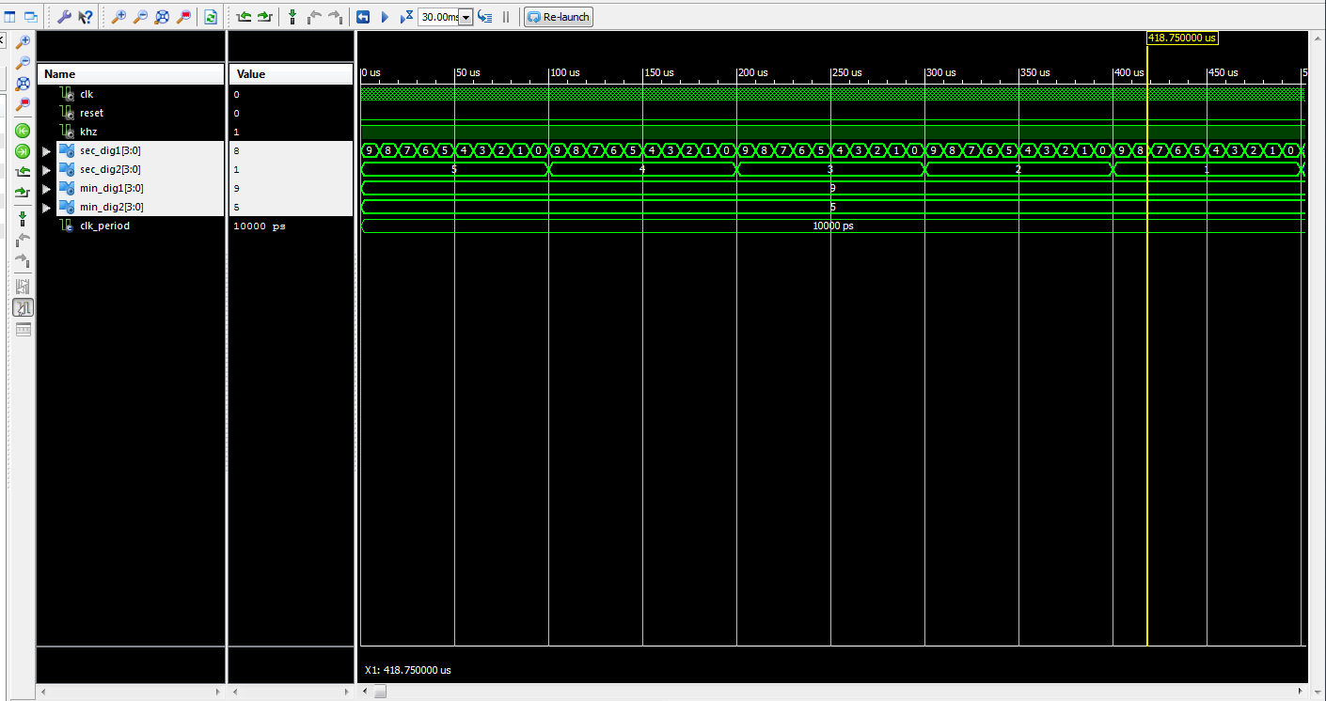

We’re seeing each of the clock digits count down from their max values to their min values, in the same order they will on the physical board. This looks exactly as we expect it to.

# PART 6

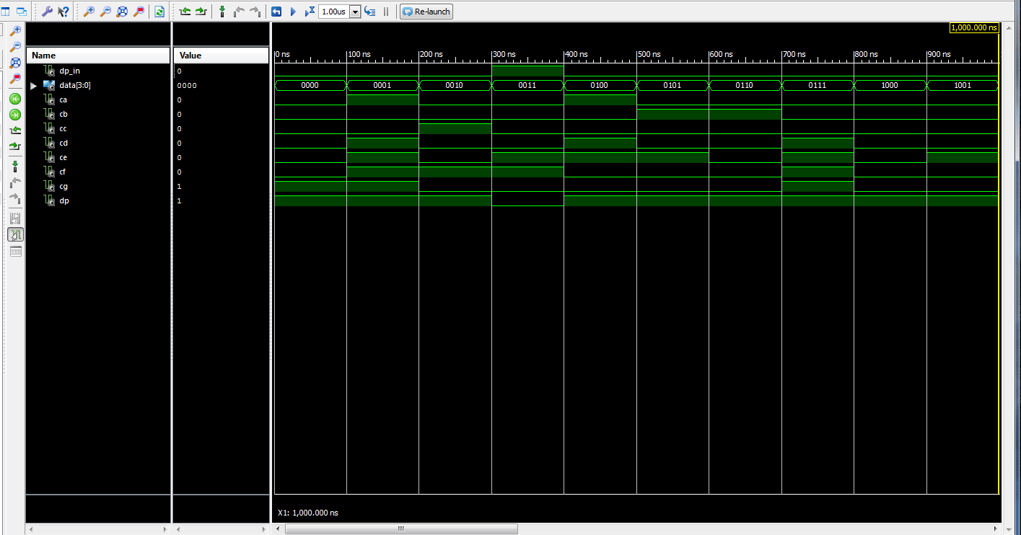

# PART 7

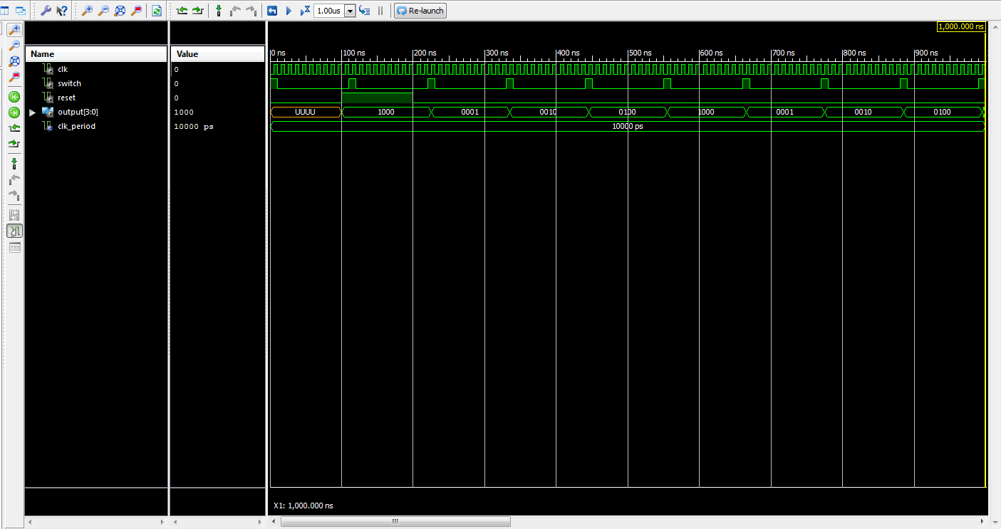

# PART 8

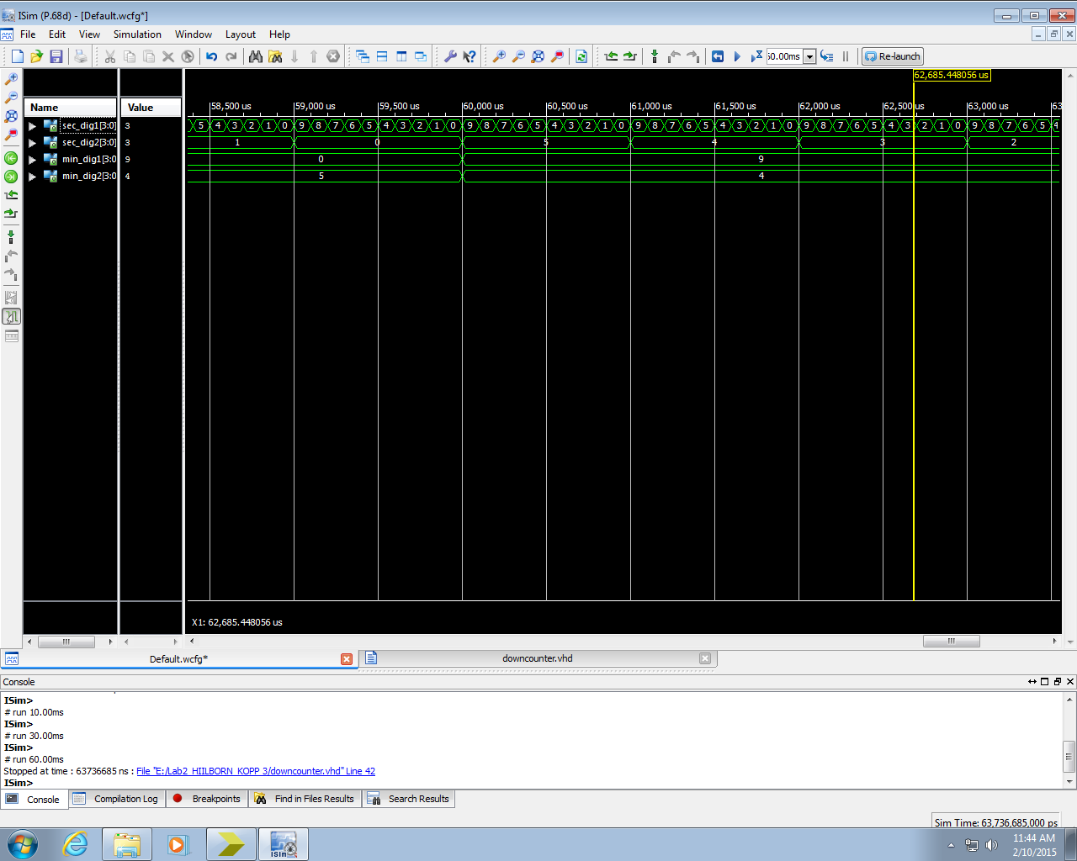

We know that it works properly because we can see each digit counting down correctly.

# PART 9

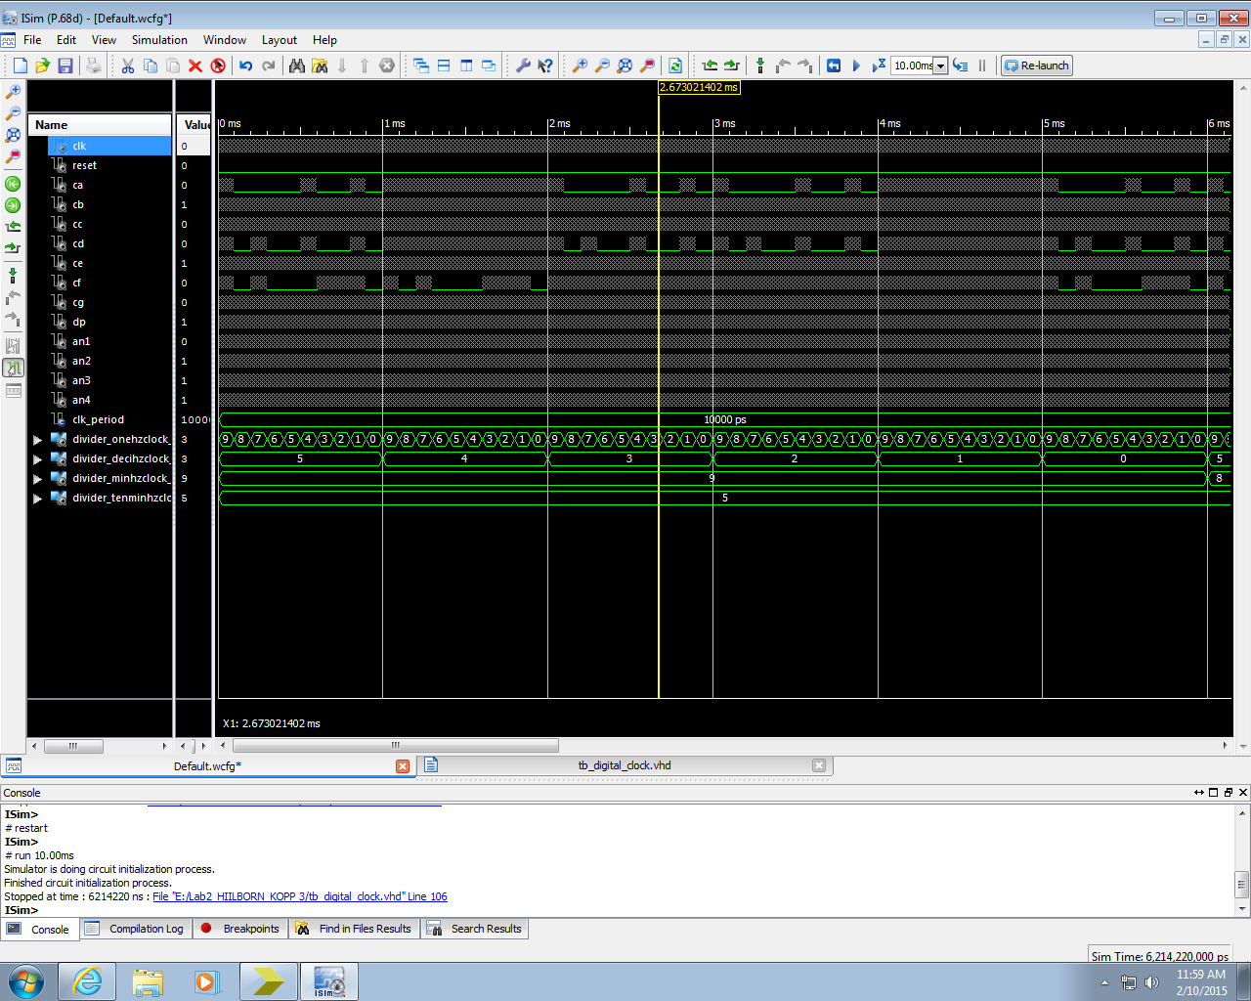

It behaves exactly as a countdown clock should.

# PART 10

1. We chose a single clock to drive all parts of the system because that ensured that every part of the system stayed in time with every other part. Even though the clock may drift, all components would be affected equally, and no timing misses would occur. Using only one oscillator also reduces power consumption over multiple oscillators.
2. Differences:
   1. Entity: The real interface. Defines how data gets in and out.
   2. Component: A virtual design unit. A blueprint for instantiation.
   3. Instance: A single defined occurrence of a component. Can have different values from other instances of same component,
3. If we created a clock divider as described, the period would be truncated and the clock divider would not divide as much as it is required to.
4. We had to add the new libraries because we need arithmetic functions for vectors and unsigned conversion and comparison functions for STD_LOGIC_VECTOR.
5. Generics are a means of passing information into an entity without declaring a specific direction.